Benefit Cost Analysis Technical Memorandum
Introduction
This technical memorandum estimates the long‐term benefits associated with the I-95/US 301 Bridge Replacements Project. This evaluation discusses the relevant Performance Outcome Criteria mentioned in the Notice of Funding Opportunity. For some measures a qualitative discussion is included. The assumptions and methods used to develop the Benefit-Cost Analysis (BCA) are detailed for each topic and are supported by supplementary material where appropriate. The BCA was calculated using the official Bridge Investment Program Benefit-Cost Analysis Tool developed by FHWA updated with default values from the BCA Guidance update (May 2025).
The long‐term quantifiable benefits presented for the Project Outcome Criteria include safety, maintenance, and environmental benefits. Benefits to resiliency are included as a quantitative benefit and are a component of the economic and innovation benefits.
The final section summarizes the anticipated benefits and costs of the I-95 and US 301 Bridge Replacements Project and calculates the overall Benefit‐Cost Ratio.
Years of Analysis
The analysis is based on the project coming online in 2030. A benefits period of 2030-2059 was used. This 30-year benefits period is consistent with the 2024 BCA Guidance for Discretionary Grant Programs (BCA Guidance) for projects involving the full reconstruction of highways or similar facilities.
Methodology
Benefits are estimated in accordance with the BCA Guidance. Where no specific approach was provided in the Guidance, NCDOT used best practices and research data as specified in the assumptions and methodology for each measure. The benefits quantified in the BCA use 2023 dollars (as advised by USDOT). Benefits for each project element are described within the benefit categories.
Analysis Assumptions
A list of assumptions for the project is provided in the BCA workbook and summarized in Exhibits 1 and 2. Exhibit 1 displays the generalized BCA input values provided by the USDOT for the relevant quantifiable benefits for this project.

Exhibit 1 ‐ Input values from BCA Guidance

Input | Value
General Assumptions
Analysis Period (Years)- Projects Involving Full Reconstruction of Highways | 30
Discount Rate | 7%
Dollar Year | 2023
Auto Occupancy (Passenger Vehicles, All Travel) | 1.52
Auto Occupancy (Trucks) ¹ | 1.00
Business Value of Travel Time (Hourly) | $33.50
Personal Value of Travel Time (Hourly) | $19.40
All Purposes Value of Travel Time (Hourly) | $21.10
Truck Driver Value (Hourly) | $35.70
Safety – Crash Data Assumptions
O – No Injury | $5,300
C – Possible Injury | $118,000
B – Non-incapacitating | $246,900
A – Incapacitating | $1,254,700
K – Killed | $13,200,000
U – Injured (Severity Unknown) | $229,800
PDO Crash | $9,500
Injury Crash | $329,500
Fatal Crash | 14,806,000
Emissions – Assumption for Damage Costs per Metric Ton
NO_{X} –2030 to 2053 | $20,900
SO_{X} – 2030 to 2053 | $56,800
PM_{2.5} – 2030 to 2053 | $1,04,100

Note: Dollar values are in 2023 dollars

Exhibit 2 lists project-specific assumptions. Most of these project-specific assumptions come from NCDOT and the National Bridge Institute (NBI).
Exhibit 2 ‐ BCA Calculation Inputs – Project-Specific
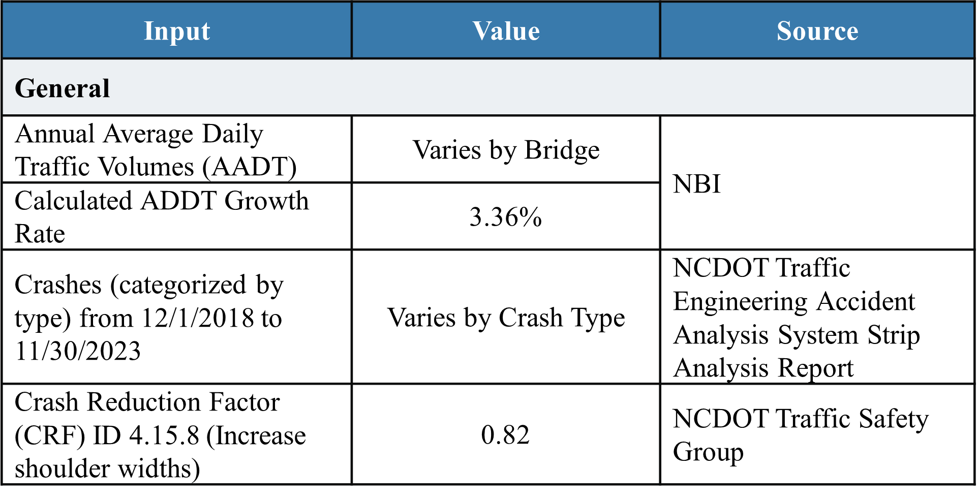

Benefits

Criterion 1 – State of Good Repair
Currently, the structures within the Project study area are contributing to an aging, deteriorating facility with frequent and expensive maintenance costs. The Project will provide improved facilities that will have less frequent and less costly maintenance. This includes pavement preservation, bridge maintenance, and general maintenance. These bridges are also being designed to have an asset life of 100 years, which brings residual benefits to the project. In the BCA spreadsheet results tab, State of Good Repair Benefits include Maintenance and Residual Value.
Altogether, state of good repair benefits will total $9.5 million.

Criterion 2 – Safety and Mobility
The benefits assigned to this criterion are focused on safety improvements. Benefits associated with mobility are grouped with economic benefits to avoid double counting. An in-depth crash strip analysis report was completed for the Project based on the 5-year period from December 1, 2018, to November 30, 2023. The crash analysis assessed all 160 crashes that occurred during this time on the Project Bridges, including a breakdown by crash type – fatal, non-fatal injuries and property damage only crashes (types A, B, and C). These breakdowns were converted to the KABCO Injury Classification Scale. Property Damage Only (O) crashes accounted for the majority (approximately 80 percent) of all crashes. Benefit values were estimated by using a combination of monetized values per injury level.
The improvements associated with the construction of the Project will enhance the safety of drivers on the facility by providing a wider shoulder. After a review of multiple Crash Reduction Factors (CRFs) from the NCDOT Traffic Safety Group (refer to Exhibit 3), it was found that an 18 percent reduction in crashes for the Project facility is a reasonable estimate based on CRF ID 4.15.8 for widening and the multiple substandard features being revised to meet current standards. Using the factors previously listed, the total safety benefit savings will total $1.4 million.
Exhibit 3 – Project Crash Reduction Factor
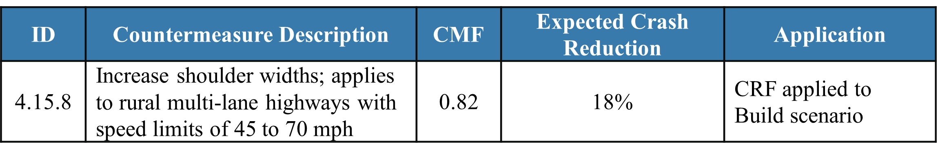

Criterion 3 – Economic Competitiveness and Opportunity
I-95 is a critical north-south corridor for passenger and freight movement in North Carolina and the east coast and US 301 is a critical redundant route for I-95 in this area. In a recent NBER Working Paper entitled Highways and Globalization, researchers quantified the value of the 20 longest interstates in the US. As a transnational route, I-95 was found to be one of the most valuable. The route was considered “extremely valuable” as it not only connects the most cities and the most major markets to one another, but also connects to major ports on the eastern seaboard. NBER research also found that the cost of removing I-95 from the Interstate Highway System (IHS) was estimated at $10.3-16.4 million per mile in 2012 dollars. Therefore, if the I-95 bridges for this project were to be closed due to structural failures, a detour along US 301 would likely be utilized. This would close 5 miles of I-95 in Johnston County. If both I-95 and US 301 were closed, a much longer detour would be required and is detailed below.
Several businesses in Johnston County rely on I-95 and US 301 for efficient transportation of agricultural products, manufactured goods, and raw materials. Of the eight counties I-95 traverses in North Carolina, Johnston County has the second greatest number of business establishments with 1,900 in 2013. The county also had the greatest number of manufacturing establishments of the eight counties with 121 establishments and an estimated 6,200 employees in 2011.
More recent data highlights the continuing importance of I-95 and Johnston County to the North Carolina economy. According to WRAL, 2025, Johnston County has experienced steady growth over the past three decades. In January 2025, there were a record 124,000 employed people in Johnston County, a 15 percent increase from the previous year. In addition, several companies are relocating or expanding operations in Johnston County, including Crystal Window and Door Systems, Veetee Foods and Novo Nordisk. All of these companies are offering jobs with pay rates higher than the statewide average. Advanced manufacturers are attracted by the proximity to a quality labor pool as well as the proximity of north-south and east-west interstates (I-40 and I-95). This location allows manufacturers to efficiently get products to customers. In fact, economic developers have labeled the five-county area including Johnston County as the BioPharma Crescent. Development has allowed more Johnston County workers to have jobs closer to their homes, reducing commute travel times and vehicle miles traveled. While this only provides qualitative data, it highlights the importance of maintaining I-95 and US 301 for freight traffic.
If the I-95 and US 301 bridges were to be closed, it would have a substantial impact on emissions due to the required offsite detour. Detour regulations in North Carolina would require NCDOT to sign an official detour route with the nearest similar facility. For I-95, if US 301 is also inaccessible, drivers would be advised to use I-40 and US 70 before reaching I-95 again. The detour to bypass the I-95 and US 301 bridges via I-40 and US 70 would add over 35 miles to travel. Local drivers or travelers using GPS may use other secondary roads to avoid the 35-mile detour but would still be met with a long detour. These drivers may be rerouted through smaller roads not designed for high volumes of traffic. The shortest possible detour to avoid both I-95 and US 301 bridges via Packing Plant Road, Black Creek Road, Thunder Road, and US 301 would be a 12-mile detour.
The impact of a potential bridge failure and the travel times associated with it were examined as a benefit. Bridge failure rates from a 2014 Utah State study were used to determine the likelihood that one or more of the I-95/US 301 bridges would fail and require detouring onto parallel facilities. The travel time savings between the current and likely detour routes were then calculated to determine the impacts. The benefit of the bridge replacement on travel time savings totals $277.6 million.

Criterion 4 –Sustainability, Resiliency, and the Environment
The extra travel miles required if I-95 and US 301 were closed within the Project area would increase emissions. To be conservative, it was estimated that the majority of travelers used the shorter, local detour route rather than the official NCDOT-signed detour route. However, due to the high traffic volumes on I-95 and US 301, BIP Large Bridge Grant funding to replace the seven bridges and avoid possible lengthy detours due to structure failure would help provide $274.5 million in benefits from reduced volatile organic compound (VOC) emissions and $2.4 million in benefits for the reduction in non – CO₂ emissions. Total emissions reduction benefits were estimated to be $276.9 million.
The Project will provide an increased ability to adapt to major weather events such as flooding. While the bridges are above the current and projected floodplain through the end of the benefits period, the No-Build alternative does not include removal of deck drains and channeling stormwater from the bridge to offsite retention areas where infiltration allows for the removal of contaminants. These measures included under the Build Alternative will reduce water runoff and pollution entering Black Creek and the Neuse River. As quantified in the BCA, the total environment benefit is $2.5 million.
Stormwater runoff is an especially important concern for the Neuse River, as it is habitat for anadromous fish such as the federally endangered Atlantic sturgeon and federally threatened Neuse River waterdog, one of the rarest Salamanders in the southeast United States. In addition, the new bridge design reduces the number of bridge bents in Black Creek and the Neuse River, improving riverbed habitat.
Further, the two bridges carrying I-95 over Black Creek were originally coated with lead paint primer, which will be removed as part of the Project. Removing the lead primer will reduce potential lead contamination in the waterway.

Criterion 5–Quality of Life
To avoid double counting, benefits quality of life are not quantified in this application. However, they can be defined and are summarized in this discussion. In terms of quality of life for those in rural communities impacted by offsite detours, keeping traffic on I-95 and US 301 will increase safety of those living along potential detours, as well as reducing emissions and noise generated by vehicles utilizing offsite detours.
As noted above, the efficient operation of I-95 and its east-west counterpart, I-40 are continuing to provide manufacturing incentives. Construction associated with replacing the I-95 and US 301 bridges will provide a stimulus to the local economy. Accommodation for a future multi-use path under the Neuse River bridge will provide a safe crossing under I-95 for those without a vehicle. The US 301 bridge over Black Creek/Holt’s Lake will provide additional width for a future multi-use path.

Criterion 6 – Innovation
The benefits related to Criterion 6 include innovations such as adding overhead dynamic message signs (DMS), evaluating innovative bridge materials, and the use of recycled concrete.
DMS benefits are not quantified to avoid any double counting with safety benefits. However, there is substantial research on how DMS can improve safety. In April 2013, Haghani et al., reported for the Maryland Department of Transportation on the effectiveness of DMS with regards to traffic flow. The study examined the effects for three types of messages:
- Type 1 – Danger Warning Messages
- Type 2 – Common Road Condition Messages
- Type 3 – Regulatory/Not Traffic-Related Messages.
Based on 2,268 cases, the study found that for Type 1 messages, driver speeds decreased by an average of 3.13 miles per hour and that decreases occurred in 17.1 percent of the cases where Type 1 messages were displayed.
Speeding is reported as common on I-95. The posted speed limit on I-95 in this area is 65 miles per hour. Of the 105 crashes reported at the I-95 bridges for this project, 12 reports listed at least one driver’s speed at 70 mph or higher at the time of the crash. This number may be an underestimation. Any measures that can quantifiably reduce speed, even for some percentage of drivers, should provide definitive benefits over time, resulting in fewer and less severe crashes.
In August 2021, Savolainen et. al, evaluated the use of DMS to display safety messages in a report sponsored by the Michigan State University Department of Civil and Environmental Engineering. Crash analyses showed that while there were no significant differences with respect to total or nighttime crashes, speeding-related crashes were significantly lower downstream of DMS that showed messages related to speeding or tailgating. The crash data analysis was complemented by a series of field studies that sought to determine the immediate impacts of safety messages on fundamental aspects of driving behavior. Drivers were shown to more frequently drive at or below the speed limit when targeted move over messages were shown as compared to standard travel time messages. The study states that, “Crashes decrease significantly based upon the frequency with which speeding and tailgating related messages are displayed. A one percent increase in the frequency of message display is associated with an average decrease of 1.5 percent in these types of crashes.”

Summary
The analysis resulted in an overall 6.74 Benefit Cost Ratio (BCR) across the seven bridges, and a $484 million net present value (see Exhibit 4). This is considered a “High” economic analysis rating. NCDOT has concluded that these benefits reasonably justify the costs of the Project.
Exhibit 4. Benefit/Cost Analysis Summary
Bridge ID | Total Discounted Costs | Total Benefits | Benefit-Cost Ration
1010037 | $23,130,245 | $166,615,104 | 7.20
1010067 | $23,255,732 | $63,726,275 | 2.74
1010056 | $6,064,767 | $185,625,316 | 30.81
1010082/85 | $15,897,105 | $54,185,038 | 3.41
1010100/101 | $15,960,990 | $97,652,016 | 6.12
Total | $84,268,840 | $567,803,749 | 6.74
Net Present Value |  | $483,534,909

Exhibit 4 – Total Project Benefit‐Cost Analysis

Values from https://www.transportation.gov/sites/dot.gov/files/2023-12/ https://www.transportation.gov/sites/dot.gov/files/2025-05/Benefit%20Cost%20Analysis%20Guidance%202025%20Update%20II%20%28Final%29.pdf
https://connect.ncdot.gov/projects/Driving95/I-95%20Economic%20Assessment.pdf
https://digitalcommons.usu.edu/cgi/viewcontent.cgi?article=3187&context=etd
https://www.fws.gov/species/neuse-river-waterdog-necturus-lewisi

